**3D Printing:** Choosing Material - Nylon, PLA, PC, ABS, Resin, ASA, and Aluminide

**Updates on Materials ordered:** Alarm system stuff, Jacob waiting on finalized sensor ?

**Pressure Sensor:**

* Jennifer found- not sure if we could use this w Arduino easily? [**https://www.mouser.com/datasheet/2/187/honeywell-sensing-micropressure-board-mount-pressu-1154293.pdf**](https://www.mouser.com/datasheet/2/187/honeywell-sensing-micropressure-board-mount-pressu-1154293.pdf)

**Jacob’s Ideas :**

1.) We **switch sensors**, from what I've seen this will be around [$14](https://www.messenger.com/t/2653727044738528#) but we need 8 so...[**$112**](https://www.messenger.com/t/2653727044738528#)on just pressure sensors rip

2.) We cut a hole in into the pvc and mount the whole chip with the pressure sensor facing the inside and then we just try and seal it with alot of sealant (silicone or whatever)

3.) we somehow attach a **casing** (either aluminium or a tube) around the square unit that has the sensor

4.) we create our **own pressure sensor**, diffcult yes but can be done maybe

5. we just put the **entire thing in the pvc** and drill small holes for wires to come out and then seal the hole with silicone. messes with air flow and theres a good chance that over time the air can cause the chip to move back and forth and tear a wire

**Goals:**

* Figure out a final design and pressure sensor

**Ideas for Pressure Sensor:**

* Solder off the pressure sensor from the breakout board and connect w wire
* Casing that is customized w the curvature of the tube
* Pitot tube idea <https://www.engineeringtoolbox.com/pitot-tubes-d_612.html>
* <https://www.youtube.com/watch?v=8YgCcV16MnU>
  + “You should get a BMP180 and follow the equations on richard shelquist's air density calculation website to properly calculate rho. Its a rough equation, but it can make your readings far more accurate. You might want to factor in some back pressure compensation to account for the total restriction of the device. I'll be doing the same sort of thing when i build my duct balometer.”
* 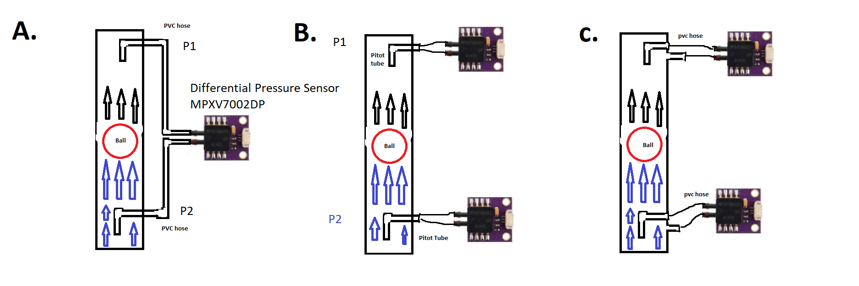<https://physics.stackexchange.com/questions/471525/differential-pressure-sensor-applications>